ProjectReport

|  |  |
| --- | --- |
| Team ID | PNT2025TMID09231 |
| ProjectName | visualizinghousingmarkettrends:ananalysis ofsalepricesand features using tableau |

# INTRODUCTION

* 1. **ProjectOverview**

The project titled **“Visualizing Housing MarketTrends: An Analysis of Sale Prices and Features using Tableau”** aims to transform raw housing data into meaningful visualinsights.Itfocusesonanalyzingfactorssuchas**yearssincerenovation,house age,numberofbathrooms,bedrooms,andfloors**,andhowtheseimpact**housesale prices**.

Using **Tableau** and **Tableau Prep Builder**, this project cleans, processes, and visualizesthedatathroughinteractivedashboardsandstorytellingfeatures.Theresultis a powerfultoolthathelpsusers **understand pricing trends**, observe **buyerbehavior**, and **explore property feature patterns** through engaging, data-driven visuals.

* 1. **Purpose**

Thepurposeofthisprojectisto:

* + - Providean**interactiveplatform**toexplorehousingmarketdata.
    - Identifyandvisualizehow**specificfeaturesandrenovations**influencehouse sale prices.
    - Helpusersunderstand**salesdistributiontrends**basedonageandrenovations.
    - Deliver**clear,visualnarratives**foranalyticalinsightsusingTableau's storytelling capability.

# IDEATIONPHASE

* 1. **ProblemStatement**

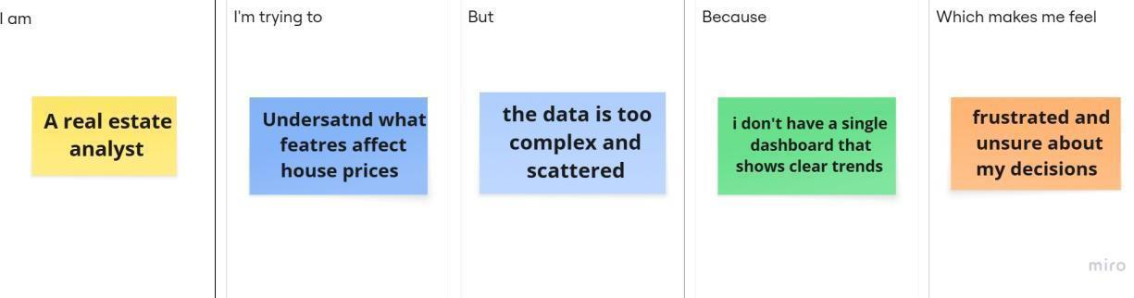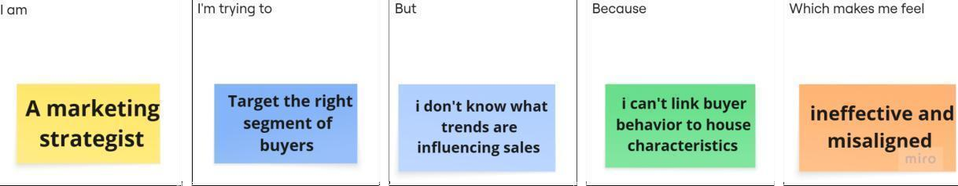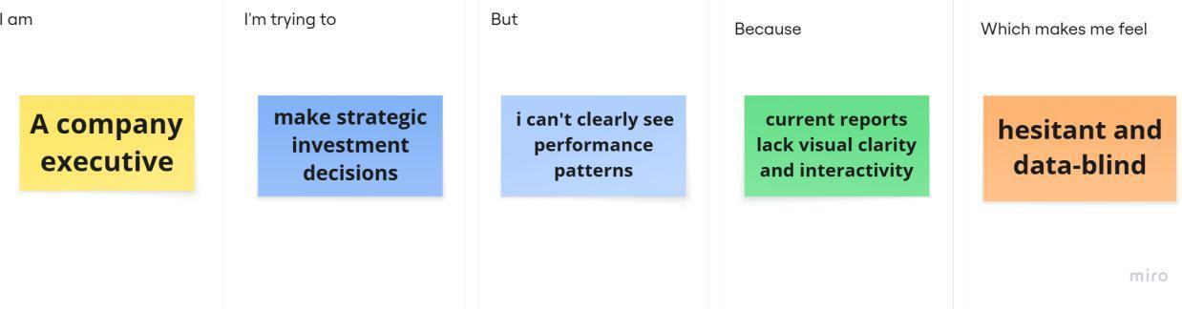

|  |  |  |  |  |  |
| --- | --- | --- | --- | --- | --- |
| **Problem Statement(PS)** | **I am (Customer)** | **I’mtryingto** | **But** | **Because** | **Whichmakesmefeel** |
| PS-1 | Arealestate analyst | understand whatfeatures affect house prices | thedatais too complex  and scattered | I don’t have a singledashboard thatshowsclear trends | frustratedandunsure about my decisions |
| PS-2 | Amarketing strategist | target the rightsegment of buyers | I don’t knowwhat trendsare | Ican’tlinkbuyer behavior to  house characteristics | ineffectiveand misaligned |

|  |  |  |  |  |  |
| --- | --- | --- | --- | --- | --- |
|  |  |  | influencing sales |  |  |
| PS-3 | Acompany executive | makestrategic investment decisions | I can’t clearly see  performanc e patterns | current reports lackvisualclarity andinteractivity | hesitantanddata-blind |

* 1. **EmpathyMapCanvas**

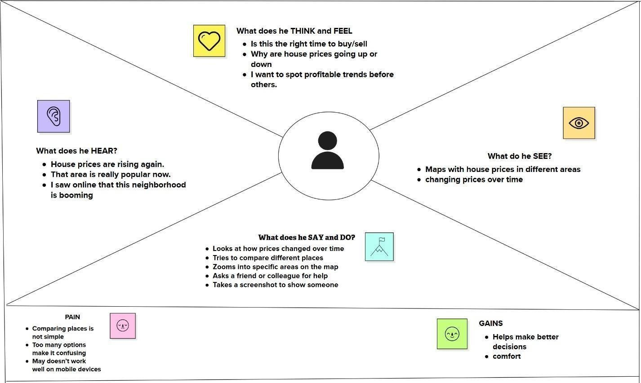

* 1. **Brainstorming**

**Step-1:TeamGathering,CollaborationandSelecttheProblemStatement**

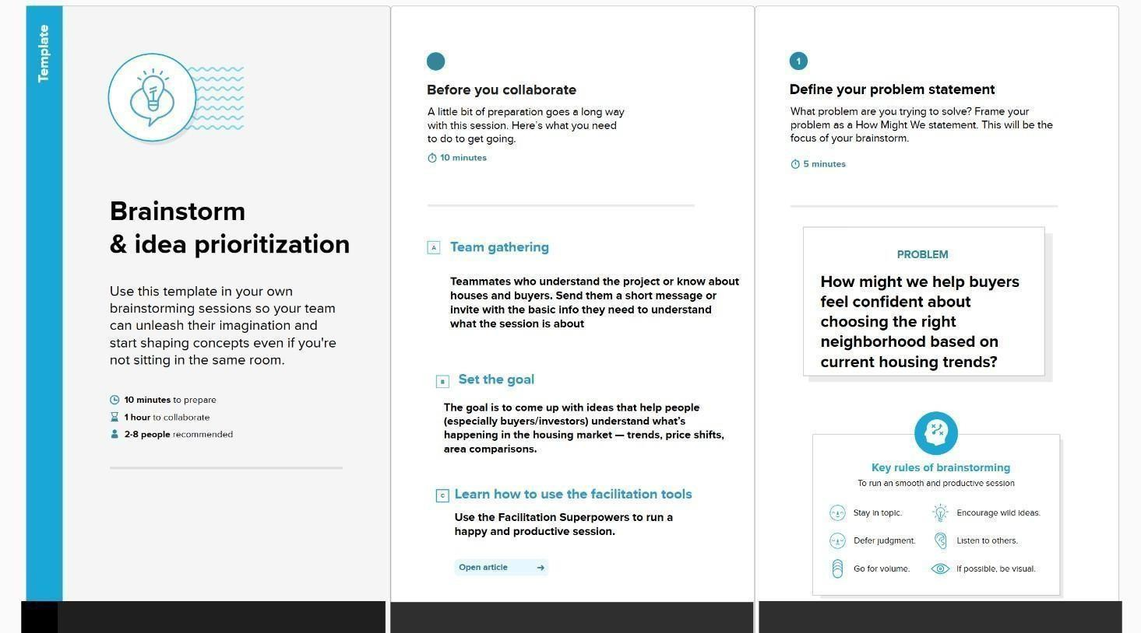

**Step-2:Brainstorm,IdeaListingandGrouping**

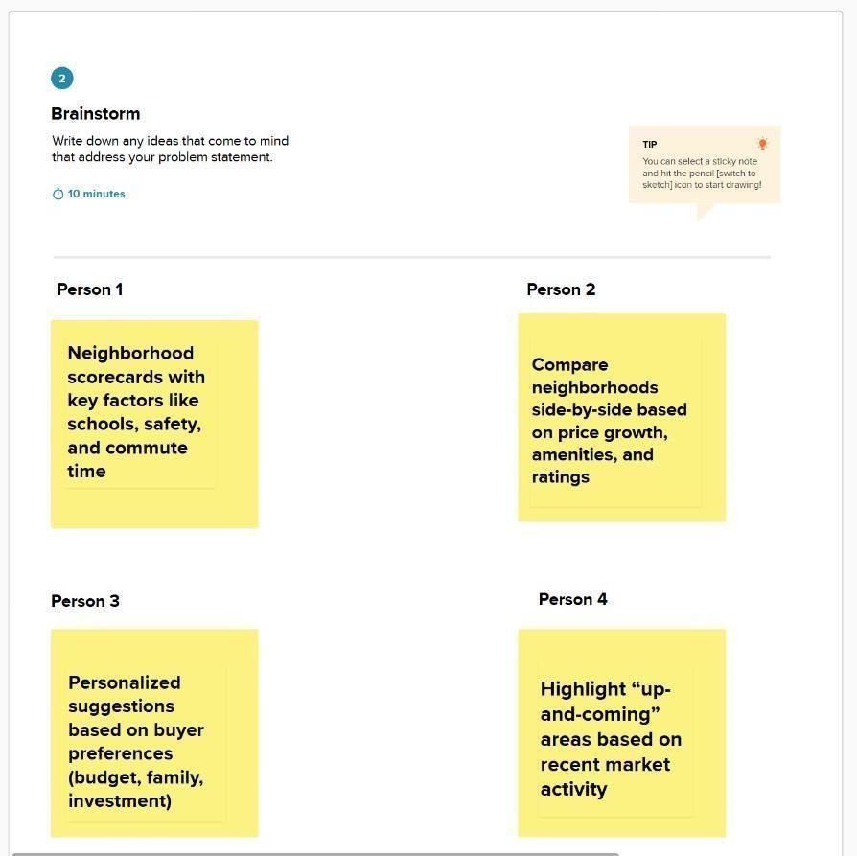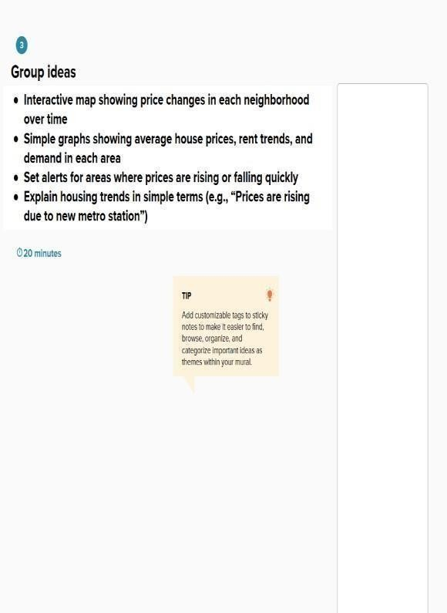

**Step-3:Idea Prioritization**

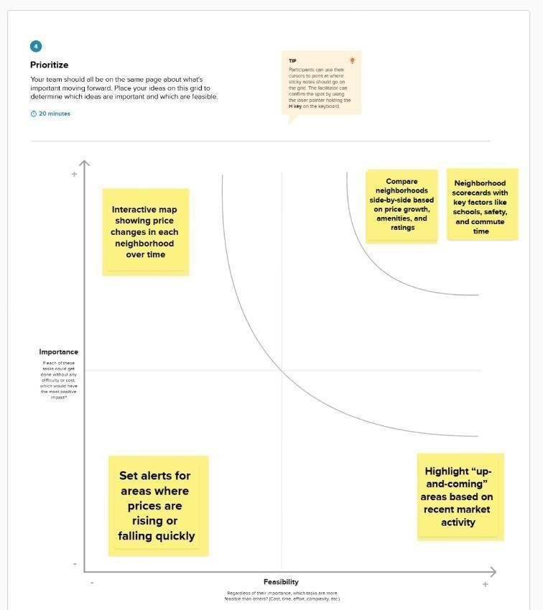

# REQUIREMENTANALYSIS

* 1. **CustomerJourneymap**

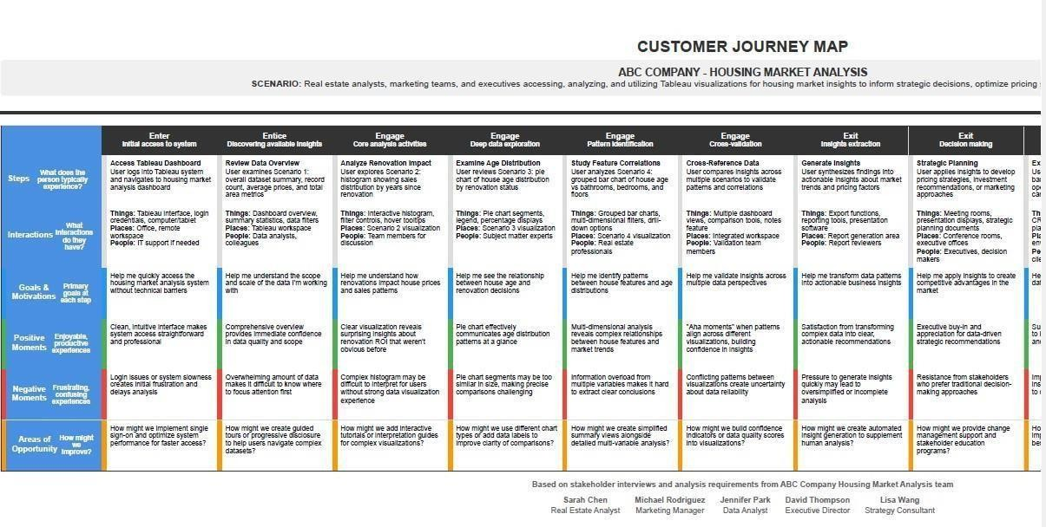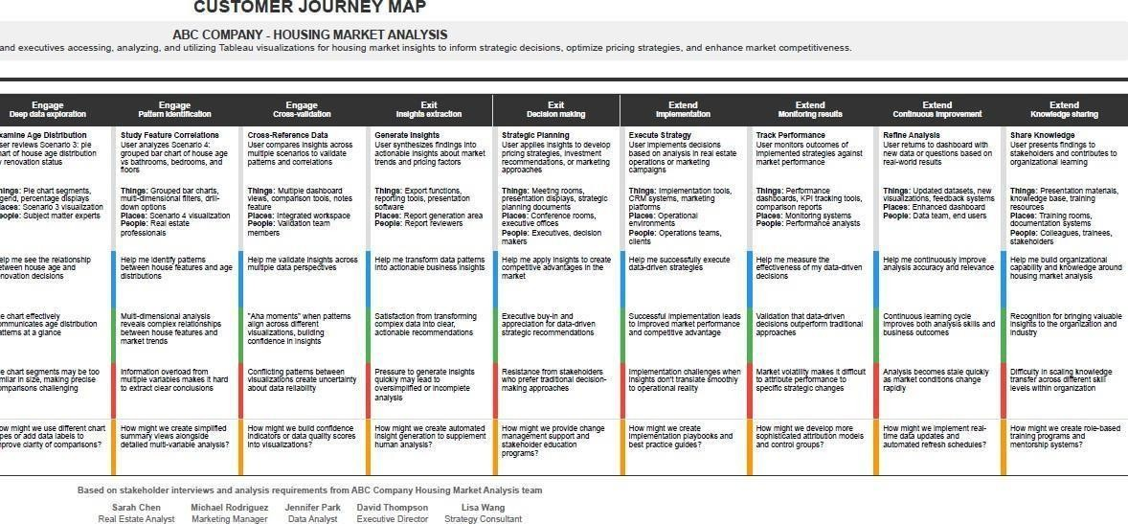

* 1. SolutionRequirement

**FunctionalRequirements:**

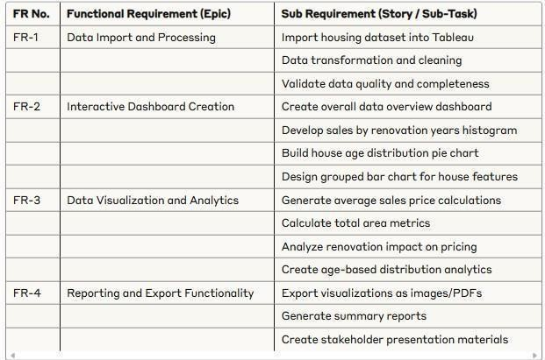

**Non-functionalRequirements:**

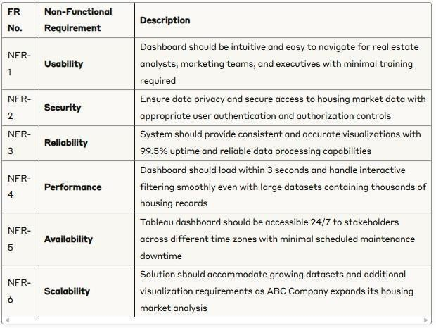

* 1. **DataFlowDiagram**

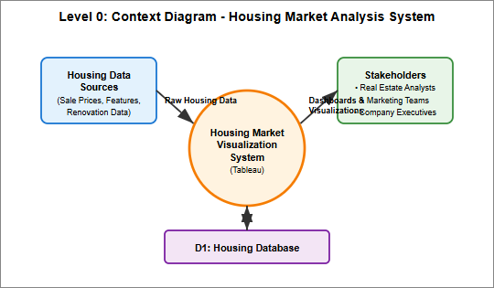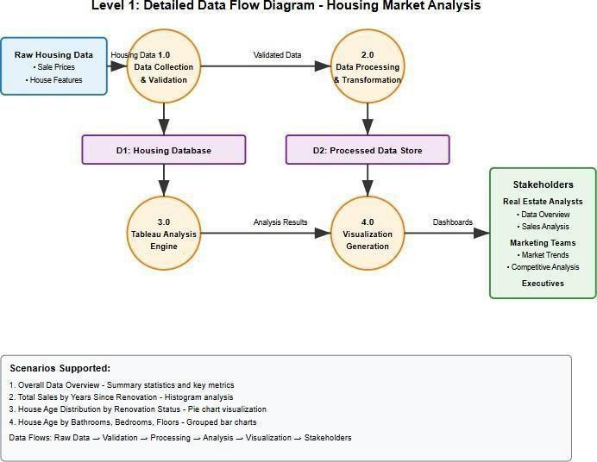

**UserStories**

Usethebelowtemplatetolistalltheuserstoriesfortheproduct.

|  |  |  |  |  |  |  |
| --- | --- | --- | --- | --- | --- | --- |
| **UserType** | **Functional**  **Requiremen t (Epic)** | **User**  **Story Number** | **UserStory/Task** | **Acceptance criteria** | **Priority** | **Release** |
| Real Estate Analyst | Data analysis &Visualization | USN-1 | As a real estate analyst,Icanviewthe overall data overview dashboardtounderstand the dataset scale and key metrics | I can see count of housing records, averagesales price, and total basementarea | High | Sprint-1 |
| Real Estate Analyst | Renovation Impact analysis | USN-2 | As a real estate analyst,Icananalyze total sales by years since renovation through histogram visualization | I can identify correlation between renovation timing and priceranges | High | Sprint-1 |
| Real Estate Analyst | HouseAge Distribution | USN-3 | As a real estate analyst, I can view houseagedistribution by renovation status through pie chart | Icanassess age characteristi cs and renovation prevalence | HIgh | Sprint-1 |
| Real Estate Analyst | Feature analysis | USN-4 | As a real estate analyst,Icananalyze houseagedistribution bynumberofbathrooms, bedrooms, and floors | I can identify patterns in housing characteristi csovertime | High | Sprint-2 |
| Real Estate Analyst | Interactive dashboard | USN-5 | As a real estate analyst, I can access an interactive dashboardcombiningall visualizations | I can navigate between different views and filterdata dynamically | Medium | Sprint-2 |

* 1. **TechnologyStack**

**Table-1: Components&Technologies:**

|  |  |  |  |
| --- | --- | --- | --- |
| **S.N**  **o** | **Component** | **Description** | **Technology** |
| 1. | UserInterface | Web-baseddashboardsforviewing and interaction | TableauPublic |
| 2. | Application Logic-1 | Datapreprocessingand transformationworkflows | TableauPrepBuilder |
| 3. | Application Logic-2 | Interactivityusingfilters,parameters, and actions | TableauFilters,Parameters, Actions |
| 4. | Dashboard/StoryLogic | Logicalflowofinsightsusingstory features | TableauStoryFeature |
| 5. | DataSource | Flatfilesusedashousingmarket datasets | CSV |
| 6. | FileStorage | Housingdatasetsstoredlocally | LocalFileSystem/Google Drive |

**Table-2:ApplicationCharacteristics:**

|  |  |  |  |
| --- | --- | --- | --- |
| **S.N**  **o** | **Characteristics** | **Description** | **Technology** |
| 1. | Open-SourceFrameworks | yes | TableauPublic |
| 2. | SecurityImplementations | N/A | N/A |
| 3. | ScalableArchitecture | CanscalebypublishingtoTableau Cloud for wider access | TableauPublic |
| 4. | Availability | Dashboardsavailableonline24/7 | TableauPublic |
| 5 | Performance | Good\Betterperformance | TableauPublic |

**TechnicalArchitecture:**

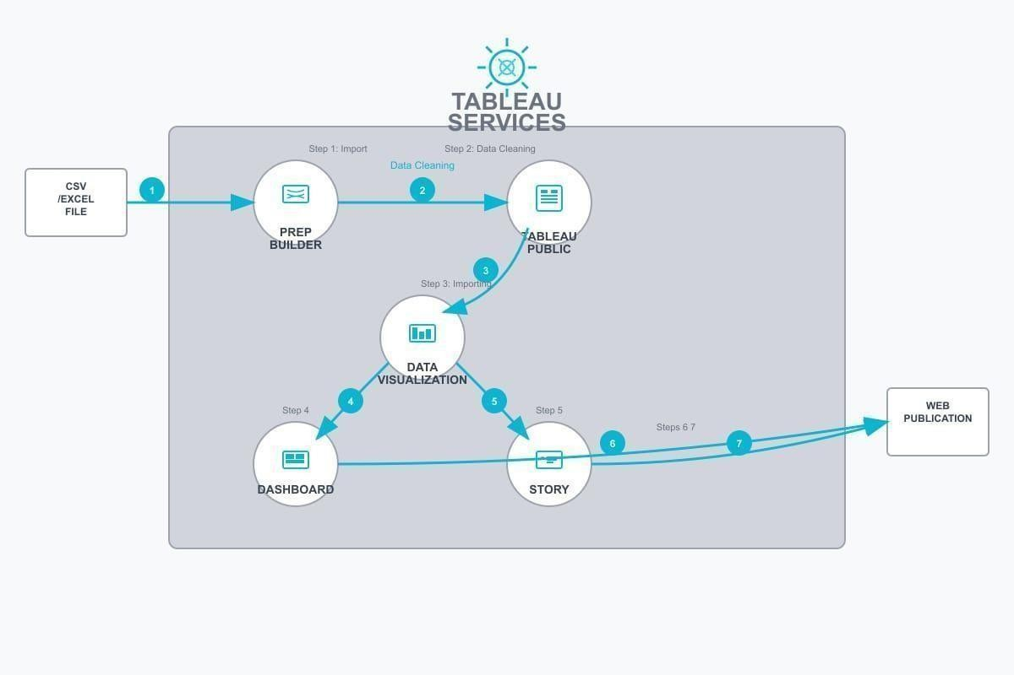

# PROJECTDESIGN

* 1. **ProblemSolutionFit**

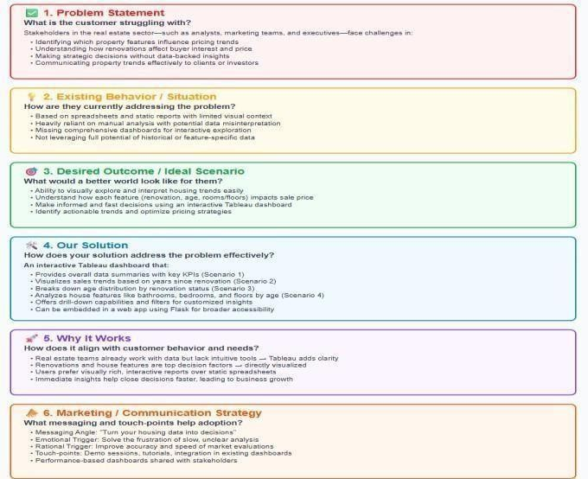

* 1. **ProposedSolution**

|  |  |  |
| --- | --- | --- |
| S.No | Parameter | Description |
|  | ProblemStatement(Problem to be solved) | The housing market often lacks clarity regarding how property renovations impact sales prices over time. Buyers and sellers struggle to assess the return on investmentforrenovationsduetothe absenceofclear dataanalytics.Thislimitseffectivedecision-makingand  marketefficiency. |
| 2. | Idea/Solutiondescription | Ourprojectaddressesthisissuebyvisualizingtotalsales in relation to the number of years since a house was renovated.UsingTableau,wecreatedahistogramthat displays how recently renovated properties correlate with various sales price ranges. This visualization  enablesstakeholderstoidentifypatternsandtrendsin buyer preferences and renovation impact. |
| 3. | Novelty/Uniqueness | Thissolutionstandsoutbyofferinganinteractive,visual dataanalysiscenteredaroundtherenovationtimeline— avariablerarelyexploredindepthintraditionalmarket reports. It brings actionable insights to the forefront using clear, user-friendly dashboards, making the data more accessible to both experts and laypeople. |
| 4. | SocialImpact/Customer Satisfaction | he solution empowers homebuyers with valuable insights into how renovation age affects home value, leadingtomoreinformedpurchasingdecisions.Italso helpssellersandagentstimerenovationseffectivelyto increase profits. Overall, it supports transparency,  enhancesconsumertrust,andcontributestobetter housing policy and urban planning. |
| 5. | BusinessModel(Revenue Model) | Thesolutioncanbemonetizedthroughasubscription- based model targeting real estate agencies, property investors,anddevelopers.Additionalincomestreams include custom dashboard development, real-time marketreporting,andintegrationserviceswithexisting property listing platforms or CRMs. |
| 6. | Scalabilityofthe Solution | This model can be extended to include multiple variables such as location, square footage, number of bedrooms,orneighborhoodcrimerates.Itcanalsoscale geographically to analyze real estate markets across different cities or countries. With integration into national real estate databases, it can provide ongoing, large-scale market intelligence. |

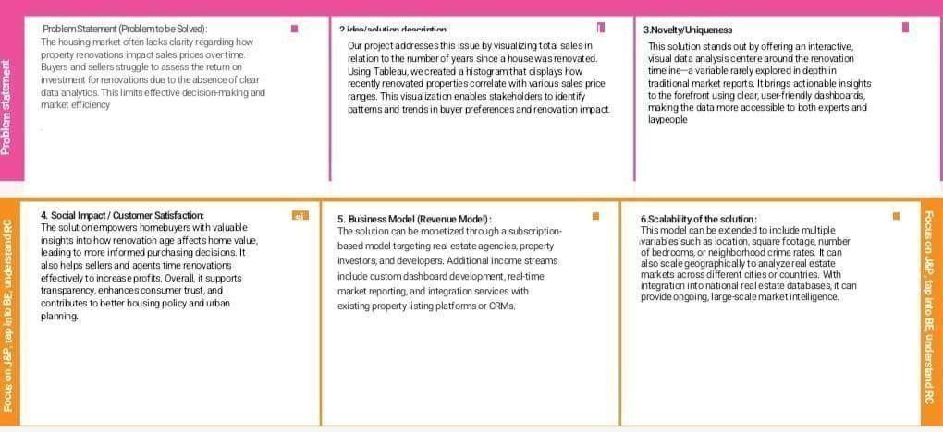

* 1. **SolutionArchitecture**

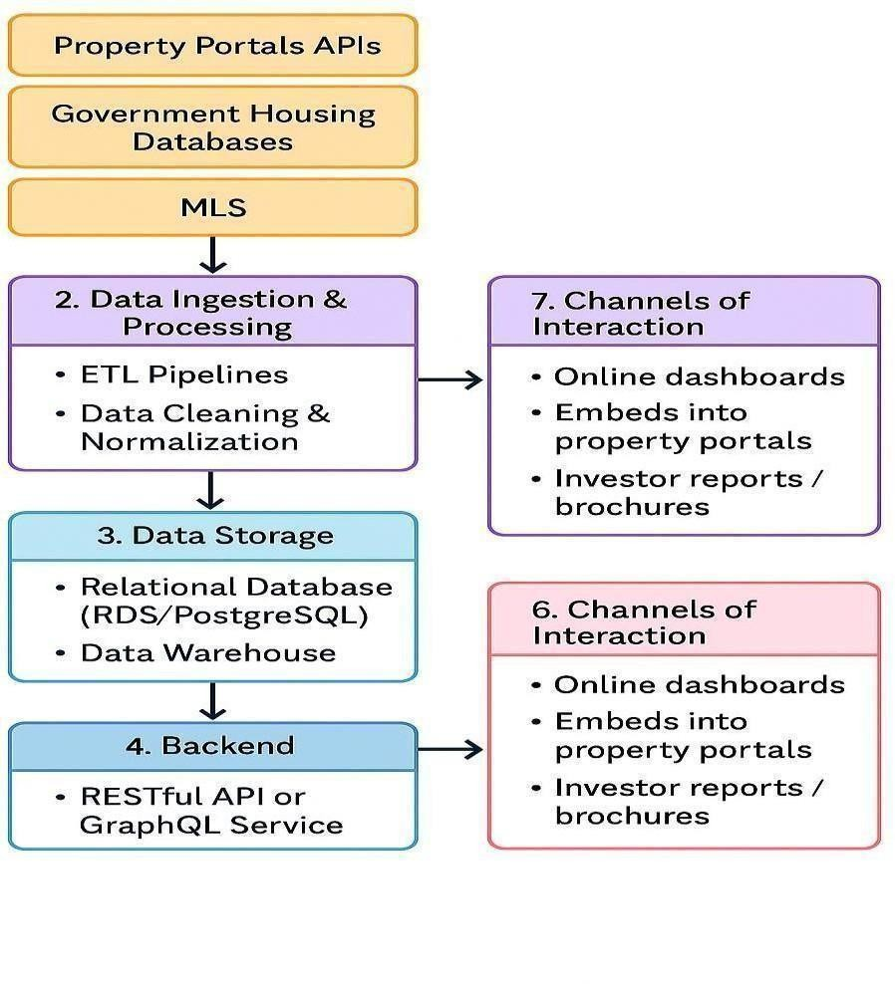

# PROJECTPLANNING&SCHEDULING

* 1. **ProjectPlanning**

**ProductBacklog,SprintSchedule,andEstimation**

|  |  |  |  |  |  |  |
| --- | --- | --- | --- | --- | --- | --- |
| **Sprint** | **Functional Requirement (Epic)** | **User Story Number** | **UserStory/Task** | **Story Point s** | **Priority** | **Team Members** |
| Sprint-1 | Data Collection&Overview | USN-1 | Asastakeholder,Iwant tocollectandtransform housing market data to createacomprehensive dataset overview. | 1 | High | Team Member-1 |
| Sprint-1 | DataAnalysis Setup | USN-2 | Asarealestateanalyst, Iwanttoloadhousing data into Tableau for visualization and analysis. | 2 | High | Team Member-2 |
| Sprint-1 | Data Preprocessing | USN-3 | As a user, I want to clean and prepare housingdataincluding salesprices,renovation years, and house features. | 2 | High | Team Member-1 |
| Sprint-2 | Renovation Impact Analysis | USN-4 | Asastakeholder,Iwant to visualize total sales by years since renovation to understandrenovation impact on pricing. | 3 | High | Team Member-1 |

|  |  |  |  |  |  |  |
| --- | --- | --- | --- | --- | --- | --- |
| Sprint-2 | Age Distribution Analysis | USN-5 | Asarealestateanalyst, I want to create a pie chart showing house age distribution by renovation status. | 3 | Medium | Team Member-3 |
| Sprint-2 | Feature- Based Analysis | USN-6 | As a marketing team member, I want to analyze house age distributionbynumber of bathrooms, bedrooms, and floors. | 3 | High | Team Member-3 |
| Sprint-2 | Dashboard Creation | USN-7 | As an executive stakeholder,Iwantan interactivedashboard combining all visualizations for strategicdecision making. | 5 | High | Team Member-1 |
| Sprint-2 | Story Development | USN-8 | Asacompanyexecutive, I want a Tableau story thatpresentsinsightsin a narrative format for presentations. | 5 | Medium | Team Member-3 |

**ProjectTracker, Velocity&BurndownChart**

|  |  |  |  |  |  |  |
| --- | --- | --- | --- | --- | --- | --- |
| **Sprint** | **Total Story Points** | **Duratio n** | **Sprint Start Date** | **SprintEnd Date (Planned)** | **StoryPoints Completed** | **Sprint Release Date** |
| Sprint-1 | 8 | 5Days | 16JULY  2025 | 20JULY2025 | 5 | 20JULY  2025 |

|  |  |  |  |  |  |  |
| --- | --- | --- | --- | --- | --- | --- |
| Sprint-2 | 18 | 5Days | 21JULY  2025 | 25JULY2025 | 19 | 25JULY  2025 |

**BurndownChart**

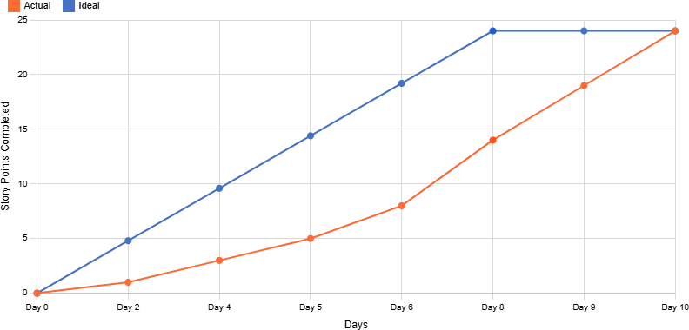

# FUNCTIONALANDPERFORMANCETESTING

* 1. **PerformanceTesting**

Projectteamshallfillthefollowinginformationinmodelperformancetestingtemplate.

|  |  |  |
| --- | --- | --- |
| **S.No.** | **Parameter** | **Screenshot/Values** |
| 1. | DataRendered | Datacontains33fieldsand21609rows |
| 2. | DataPreprocessing | Identified11duplicaterows,removedunnecessarycolumnslike    zipcodes,nomissingornullvalues. |

|  |  |  |
| --- | --- | --- |
| 3. | UtilizationofFilters | Forscenario–1    Forscenario–2    Forscenario– 3 |

|  |  |  |
| --- | --- | --- |
|  |  | Forscenario–4 |
| 4. | CalculationfieldsUsed |  |
| 5. | Dashboarddesign | NoofVisualizations/Graphs–4 |

|  |  |  |
| --- | --- | --- |
|  |  |  |
| 6 | StoryDesign | NoofVisualizations/Graphs–4 |

# RESULTS

* 1. **OutputScreenshots**

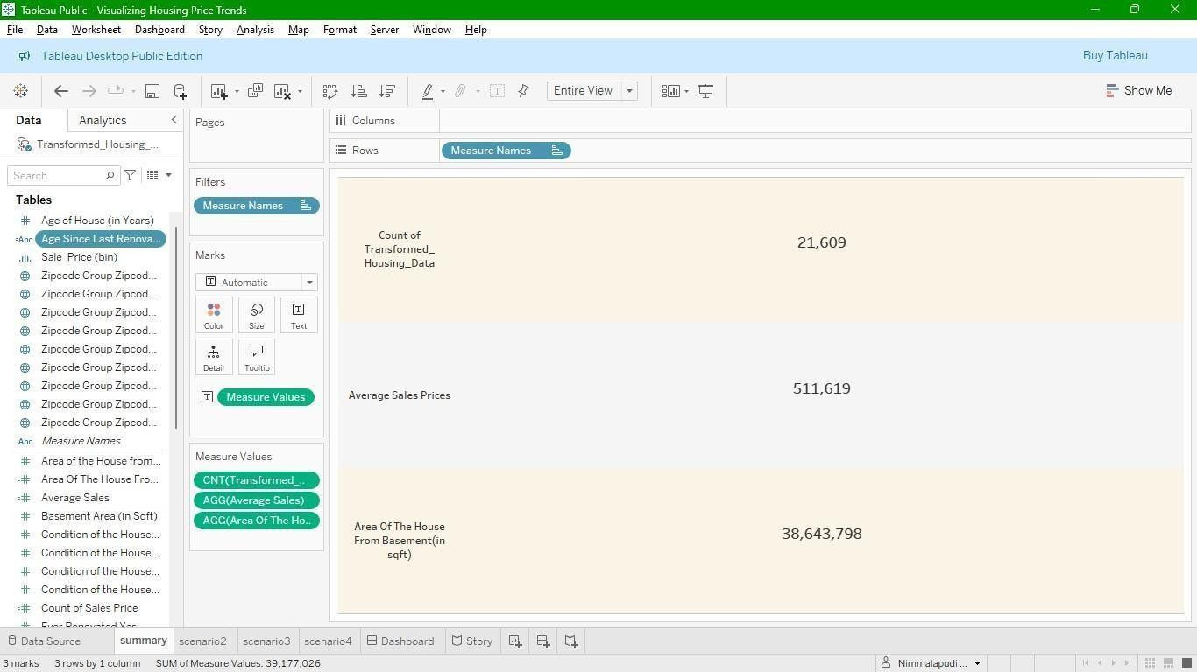Scenario-1

Scenario-2

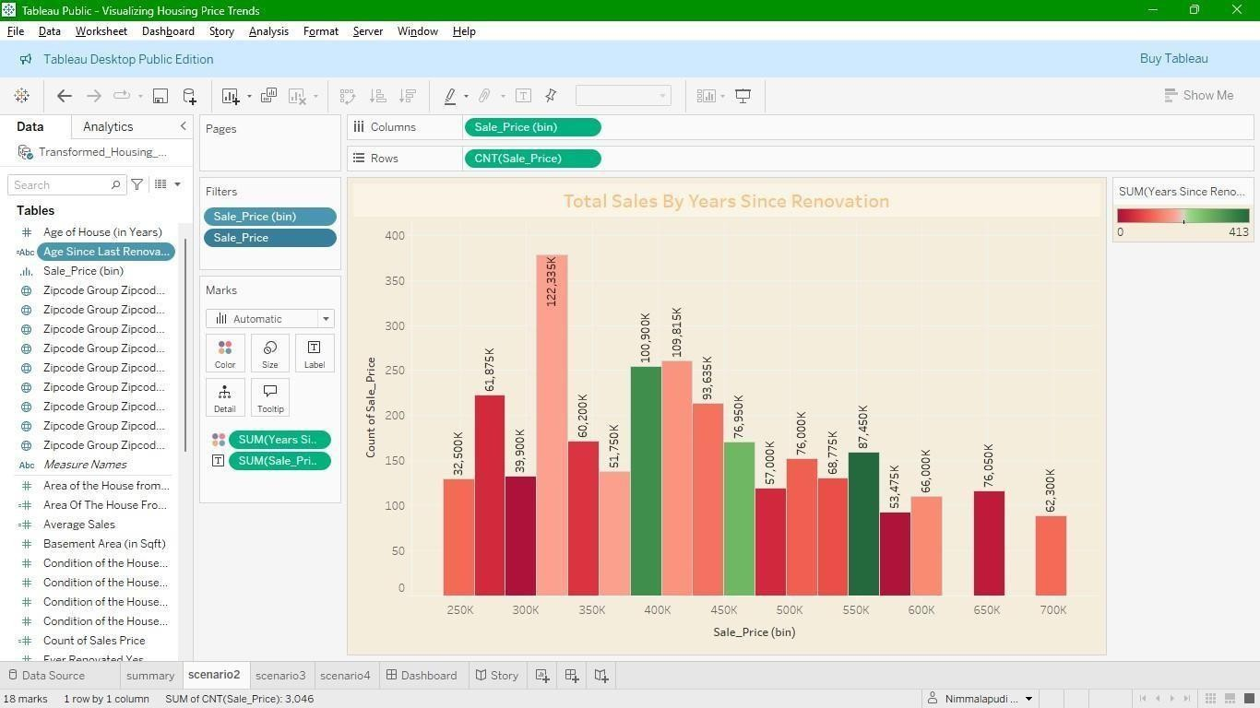

Scenario-3

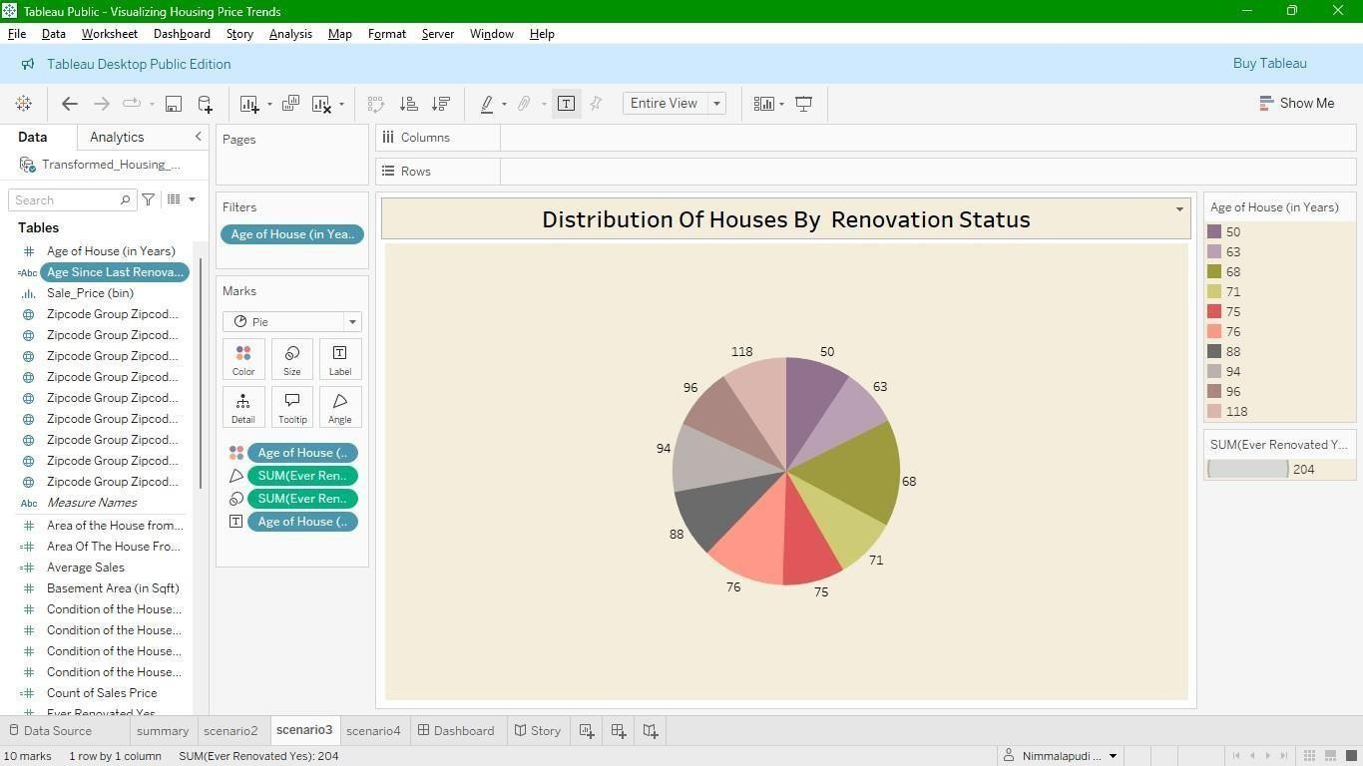

Scenario-4

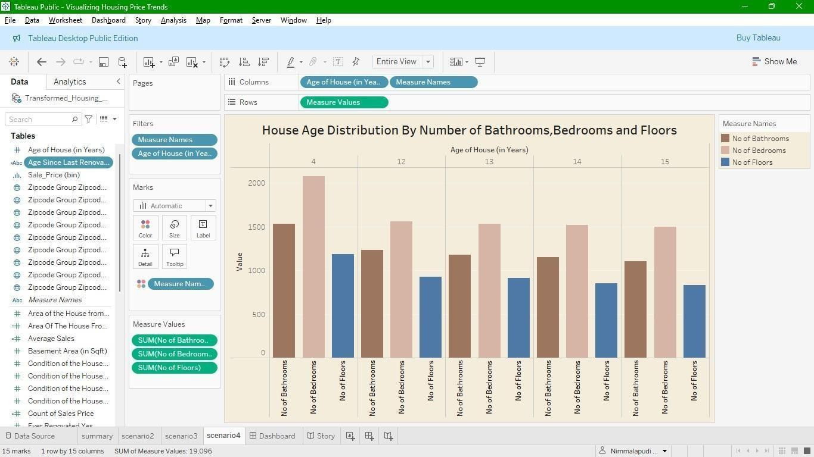

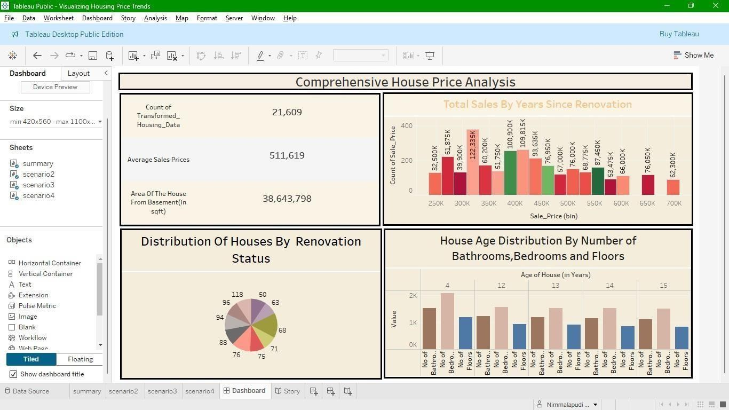Dashboard

Story

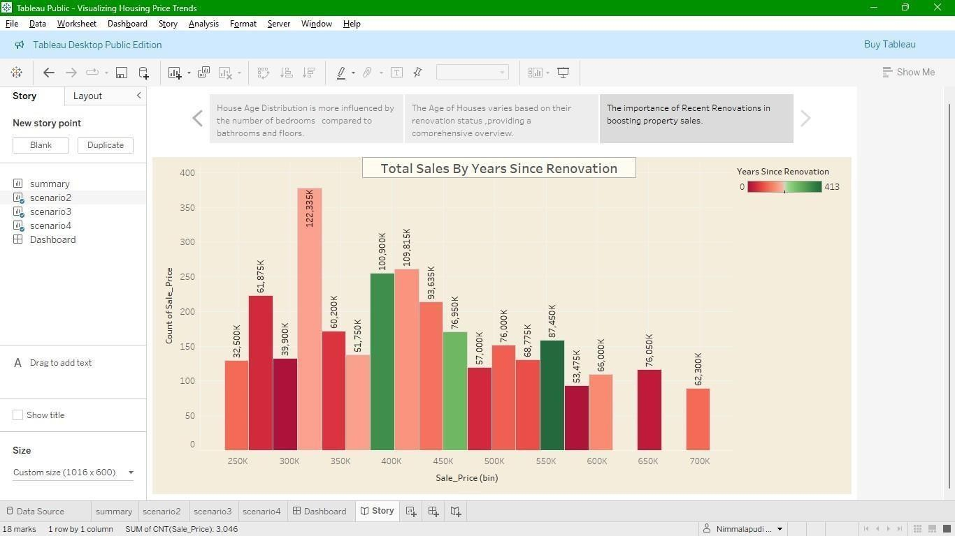

# ADVANTAGES&DISADVANTAGES

* 1. **ADVANTAGES**

1. **VisualClarity**:Tableauenablesintuitive,easy-to-understandvisualizationsforcomplex housing datasets.
2. **InteractiveDashboards**:Userscanfilterdatadynamicallybasedonfeatureslike renovations, age, or number of rooms.
3. **BusinessInsights**:Helpsstakeholdersidentifytrendsandpatternsthatinfluence pricing strategies and buyer behavior.
4. **Time-Efficient**: Reducesmanualanalysisthroughautomatedandvisualinsights.
5. **StorytellingCapability**:Tableau’sstoryfeatureallowspresentingdataasstep-by-step narratives.
6. **Non-technicalAccessibility**:Designedforbusinessuserswithminimaltechnicalskills.
7. **ImprovesDecisionMaking**:Enhancesstrategicplanningthroughdata-driven recommendations.
8. **FlexibleDataSources**:SupportsawiderangeofformatslikeExcel,CSV,andcloud- based data.
   1. **DISADVANTAGES**
      1. **NoPredictiveModeling**:Tableaulacksbuilt-inmachinelearningorforecasting capabilities.
      2. **DependenceonDataQuality**:Inaccurateoruncleandatacanleadtomisleading visualizations.
      3. **LimitedData Cleaning**:Complexdata transformationsrequire externaltoolslike Tableau Prep.
      4. **PerformanceIssues**:Canslowdownwithverylargedatasetsifnotoptimizedproperly.
      5. **StoryLimitations**:Tableau’sstoryfeatureisstaticandnotasflexibleasinteractive dashboards.
      6. **Cost(forfullversion)**:TableauCreatorlicensesand cloudsolutionsmaybeexpensive.
      7. **NoNativeReal-TimeStreaming**:Tableauisnotidealforreal-timedynamicupdates.
      8. **RequiresTraining**:Usersneedtimetobecomeproficientindesigningmeaningful dashboards.

# CONCLUSION

This project demonstrates the effective use of**Tableau** and **Tableau Prep Builder** to analyze and visualize housing marketdata ina meaningfuland interactive way. By examining patterns related to**sale prices, renovations, house age,and structural features**,theprojectreveals key insights that support a deeper understanding of real estate trends.

Through a combination of **interactive dashboards** and **story-driven visualizations**, the project transforms raw datasets into easily interpretable insights. It proves how data visualization can **enhance clarity, support decision-making**, and provide a **structured narrative**aroundcomplexdatasets.Theapproachusedensuresthefindingsareaccessibleto bothtechnicalandnon-technicalusers,makingitavaluableassetforrealestatedataanalysis.

# FUTURESCOPE

1. **AddPredictiveAnalytics**:Integratemachinelearningto forecasthousingprices.
2. **UseReal-TimeAPIs**:ConnecttorealestateAPIs(likeZilloworRealtor.com)forlive data updates.
3. **EnhancewithMaps**:UseTableau’smapvisualizationsforgeospatialhousingtrends.
4. **DeployonTableauServer**:Expandcollaborationthroughserver-hosteddashboards.
5. **IncludeExternalData**:Addeconomic,demographic,orregionaldatatoenrichinsights.
6. **MobileDashboards**:Optimizedashboardsformobileaccessibility.
7. **AutomatedDataRefresh**:Scheduleregularupdatesfromconnecteddatasources.
8. **Multi-UserInteraction**:Enabletailoredviewsfordifferentusertypeslikeanalysts, buyers, or planners.